**Aviva Web Assignment Execution Report Document:**

**Project Structure:**

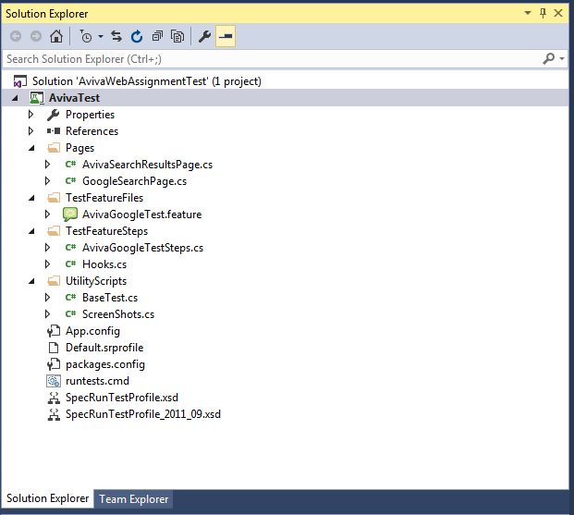

**Aviva Web Assignment consists of below files:**

1. **Aviva Test Feature consists of positive and negative scenarios.**

**TestFeatureFile-🡪AvivaGoogleTest.feature**

1. **Aviva Step Definition : Test Feature Step🡪AvivaGoogleTestSteps**
2. **Pages : GoogleSearchPage, AvivaSearchResultsPage**
3. **Utility Scripts :Base Test ,ScreenShots**

**Step1: Steps to Execute AvivaWebAssignment from command Prompt:**

1. Extract Aviva Test Solution folder
2. Navigate to below path from cmd:

D:\Divya_Assesment\AvivaAssessment_Divya\Divya_Gurram_Aviva\AvivaTestSolution\packages\SpecRun.Runner.1.6.1\tools

1. Run with the below command:

SpecRun.exe run default.srprofile /baseFolder:D:\Divya_Assesment\AvivaAssessment_Divya\Divya_Gurram_Aviva\AvivaTestSolution\AvivaTest\bin\Debug /outputFolder: D:\Divya_Assesment\AvivaAssessment_Divya\Divya_Gurram_Aviva\AvivaTestSolution\TestResults /report:myreport.html /log:specrunTest.log

Run below command from cmd:

**OR**

**Step2: Steps to Execute AvivaWebAssignment from command Prompt:**

1. Build project from visual Studio 2015
2. Navigate to Folder Aviva Test
3. Double click on “ runtests.cmd”

It will launch command prompt with the execution of Specflow scripts.

Execution report will be updated with screenshots can be found at

**Path: ex:** **D:\Divya_Assesment\AvivaAssessment_Divya\Divya_Gurram_Aviva\AvivaTestSolution\TestResults**

**Steps to Execute AvivaWebAssignment from Visual Studio IDE :**

1. **Extract Aviva Test Solution to a folder.**
2. **Click on AvivaWebAssignmentTest.sln to launch project in visual studio in 2015 IDE.**
3. **Build Project and click on “RUN ALL”. This will launch execution of 2 feature files positive and negative scenarios.**
4. **Execution reports can be found in output console.**

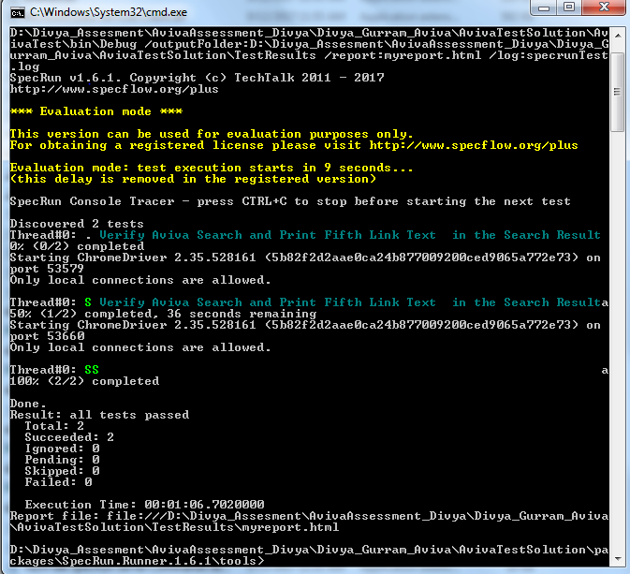

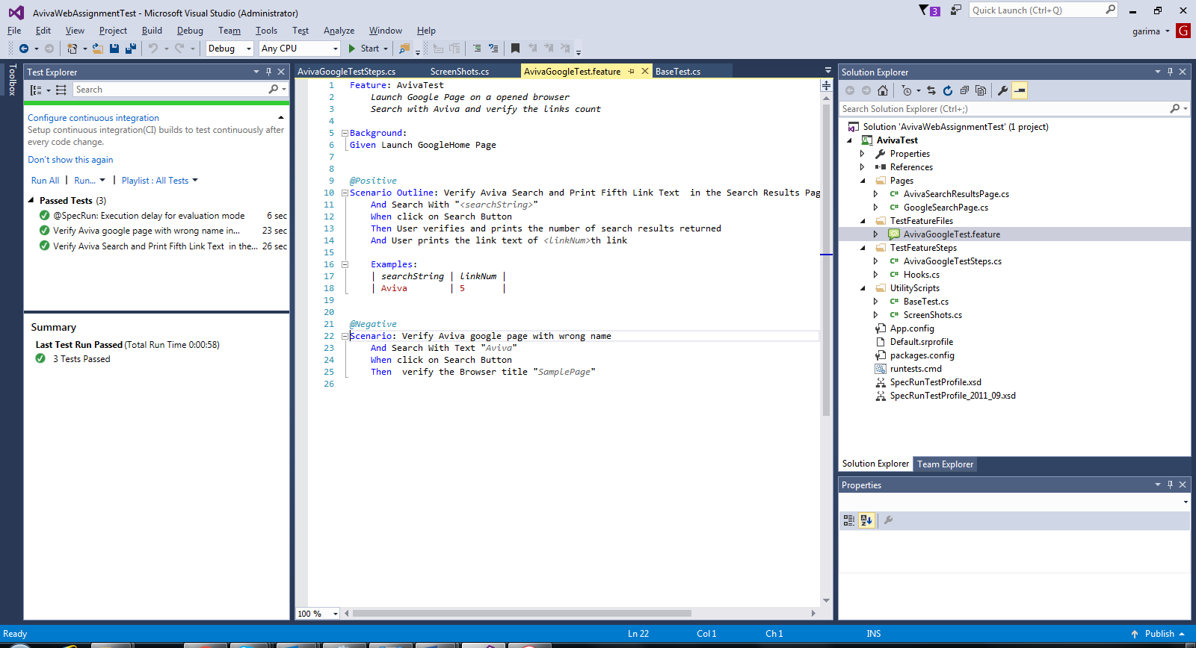

Execution Report Screenshot 1:

